[Validation] Opt out of static SSR browser validation (69528)
Test Report
- Build Tested: .NET SDK 11.0.100-rc.1.26425.128; ASP.NET Core Runtime 11.0.0-rc.1.26425.128
- Configuration Tested: Blazor Web App (Static SSR)
- Also Exercised: None
- OS, Browser, IDE: Windows 11, Microsoft Edge, Visual Studio
- Sample: blazor-static-ssr-optout-validation/Samples/StaticSSROptOutValidation
- Outcome: Validation Passed

Repository Revision
- Repository: BrundhaVelusamy/blazor-static-ssr-optout-validation
- Branch: main
- Commit:
Scenario | Commit
DisableClientValidation = false | 57f4d82e70f3495136d952a80bd0f6dafdc00d59
DisableClientValidation = true | bfff8d1510e24d8a6f0fa9b814ca5e72625af283

.NET SDK Detail:

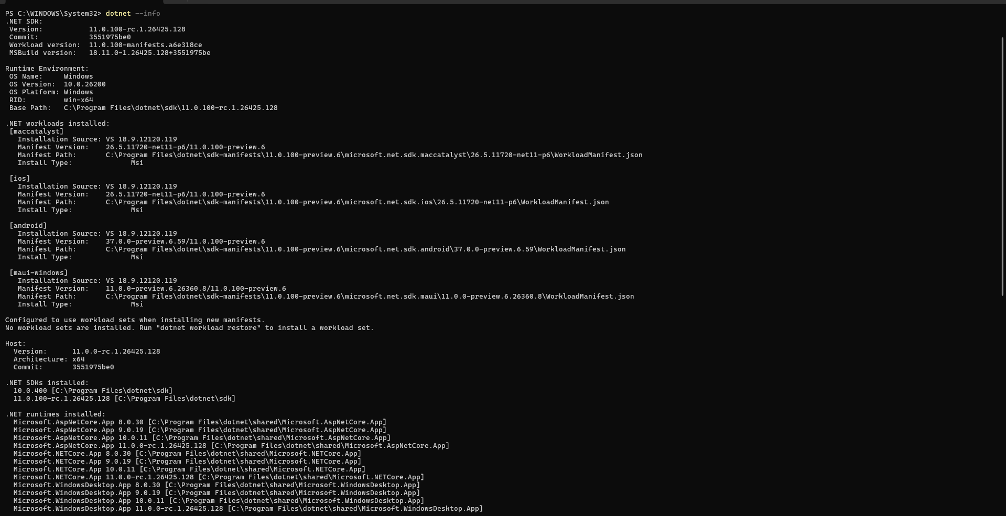

Validation Methodology
- Validation was performed manually using a Static SSR Blazor application.
- Browser DevTools (Network tab) were used to verify whether form submissions generated HTTP POST requests.
- Two execution runs were performed:
  - App-wide client validation enabled (DisableClientValidation = false)
  - App-wide client validation disabled (DisableClientValidation = true)
- Both invalid and valid form submissions were tested for each form.

Checks
S. No | Check | Result | Comments
 | With app-wide option off, submit the Default Form with the required field empty. Verify whether a validation message appears and whether a POST occurs. | Pass | The validation message "Name is required." was displayed immediately. The form submission was blocked in the browser and no POST request was observed in the Network tab.
 | With app-wide option off, submit the Opted-Out Form with the required field empty. Verify whether a POST occurs and whether server validation is returned. | Pass | A POST request was generated and observed in the Network tab. The server returned validation feedback, including "Name is required." and the configured server validation status message.
 | With app-wide option off, correct the entry and submit the Default Form. | Pass | A valid value was accepted. The form successfully posted to the server and displayed the success message.
 | With app-wide option off, correct the entry and submit the Opted-Out Form. | Pass | A valid value was accepted. The form successfully posted to the server and displayed the success message.
 | Enable the app-wide opt-out (DisableClientValidation=true) and submit the Default Form with an empty required field. | Pass | Browser validation was disabled. The invalid submission reached the server through a POST request and server-side validation messages were returned.
 | Enable the app-wide opt-out (DisableClientValidation=true) and submit the Opted-Out Form with an empty required field. | Pass | The invalid submission reached the server and produced server-side validation messages. POST activity was visible in the Network tab.
 | With app-wide opt-out enabled, correct the entry and submit the Default Form. | Pass | The valid value was accepted and the form submission completed successfully.
 | With app-wide opt-out enabled, correct the entry and submit the Opted-Out Form. | Pass | The valid value was accepted and the form submission completed successfully.

Evidence
Check | Evidence
Default form invalid submission blocked without POST (App-wide option OFF) | DefaultForm_Invalid_NoPOST.png
Opted-out form invalid submission generates POST (App-wide option OFF) | OptedOutForm_Invalid_POST.png
Default form valid submission (App-wide option OFF) | DefaultForm_Valid_POST_Success.png
Opted-out form valid submission (App-wide option OFF) | OptedOutForm_Valid_POST_Success.png
Default form invalid submission generates POST (App-wide option ON) | GlobalOptOut_DefaultForm_Invalid_POST.png
Opted-out form invalid submission generates POST (App-wide option ON) | GlobalOptOut_OptedOutForm_Invalid_POST.png
Default form valid submission (App-wide option ON) | GlobalOptOut_DefaultForm_Valid_POST_Success.png
Opted-out form valid submission (App-wide option ON) | GlobalOptOut_OptedOutForm_Valid_POST_Success.png

Unexpected Behavior
No unexpected behavior was observed.

Documentation Sufficiency Verdict
Sufficient
The documentation provides enough information to successfully build, configure, and validate the scenario covered by [Validation] Opt out of static SSR browser validation (69528). The guidance accurately describes the validation mechanisms and opt-out capabilities, and the observed behavior matched the documented expectations. Additional end-to-end examples and network-level explanations would improve developer usability, but no blockers were encountered during validation.

Final Verdict
Validation Passed
The sample successfully demonstrated per-form and app-wide opt-out of static SSR browser validation. All required scenarios, expected behaviors, must-hold conditions, and network validation checks were verified successfully.

